**Outputs For**

**CI/CD Deployment for Springboot Application**

**Flow chart:**

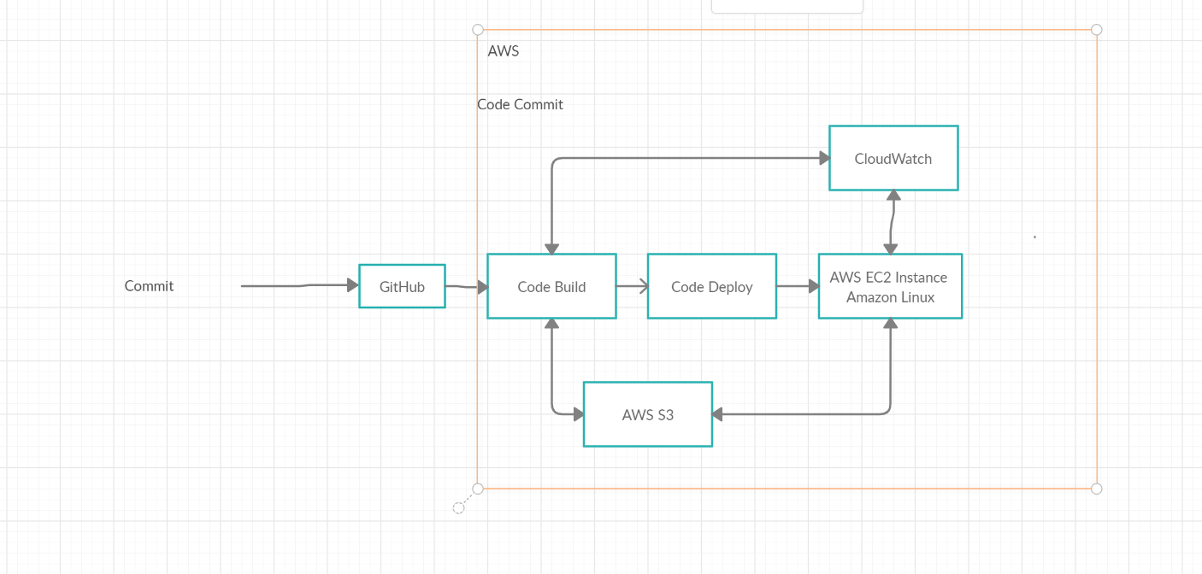

# Eclipse:

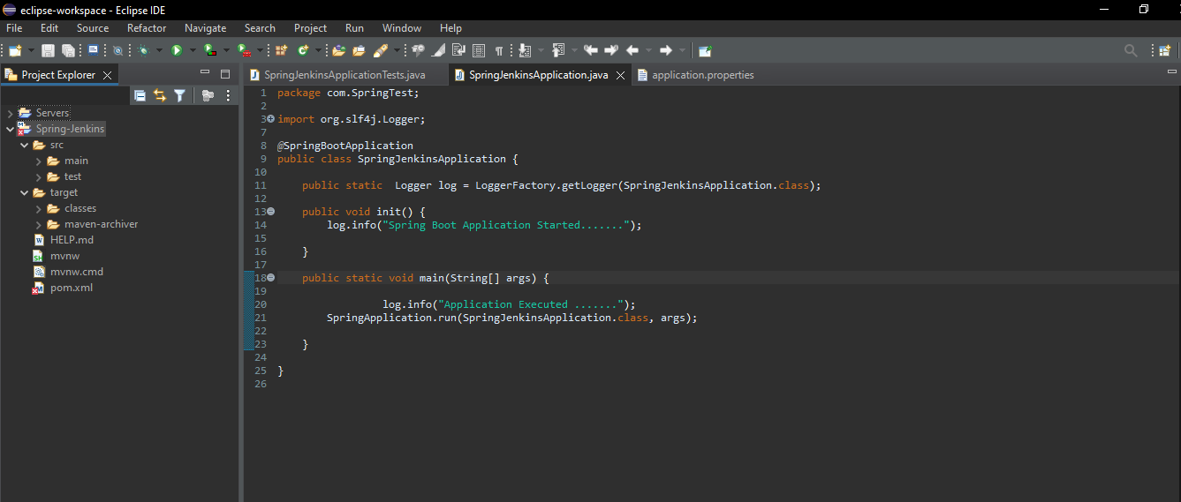

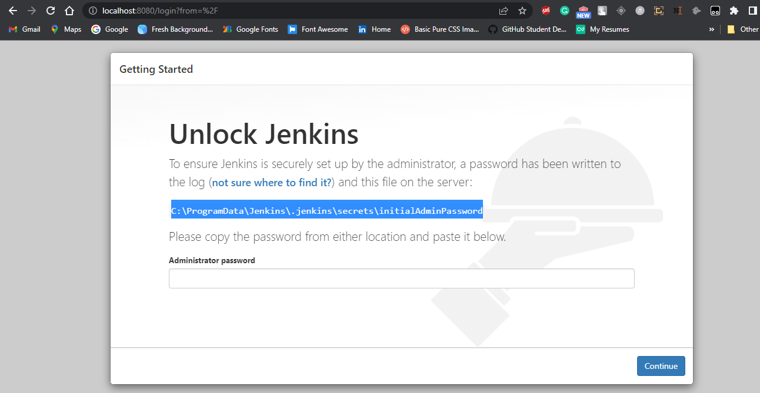

# I created a Simple Spring boot Application to build a CI/CD pipeline to demonstrate continuous deployment:

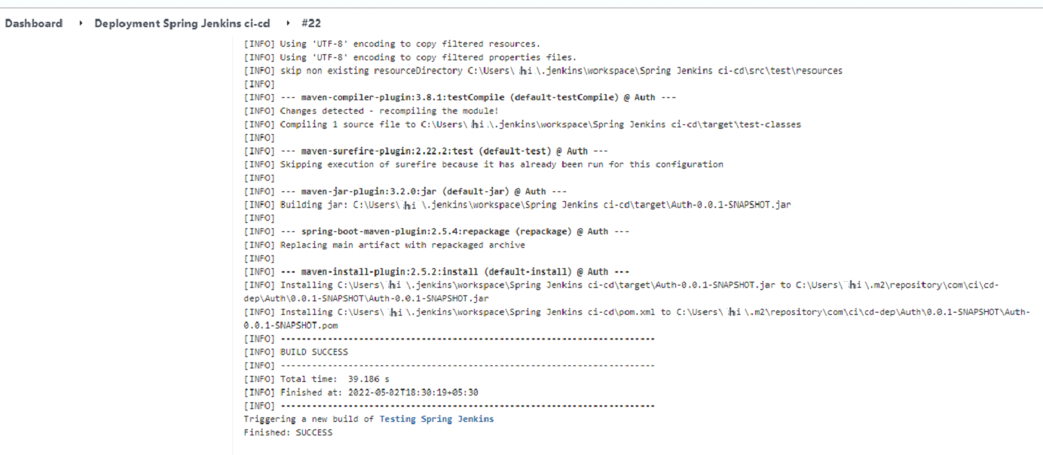

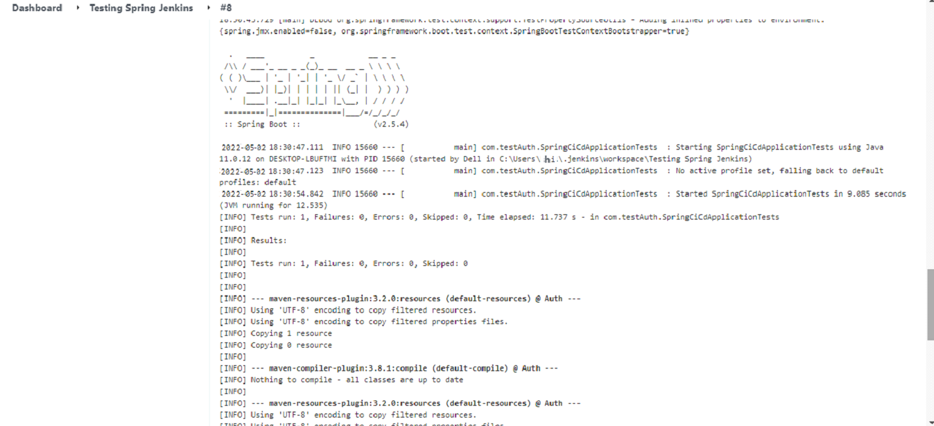

# Jenkins: Run Jenkins

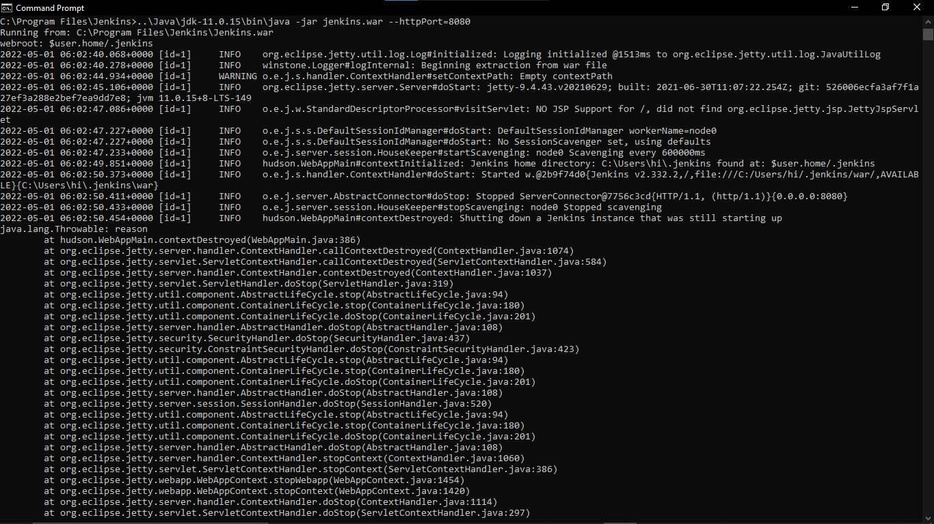

**Create Three Jenkins Project Deployment:**

**(Deployment-Testing-Production)**

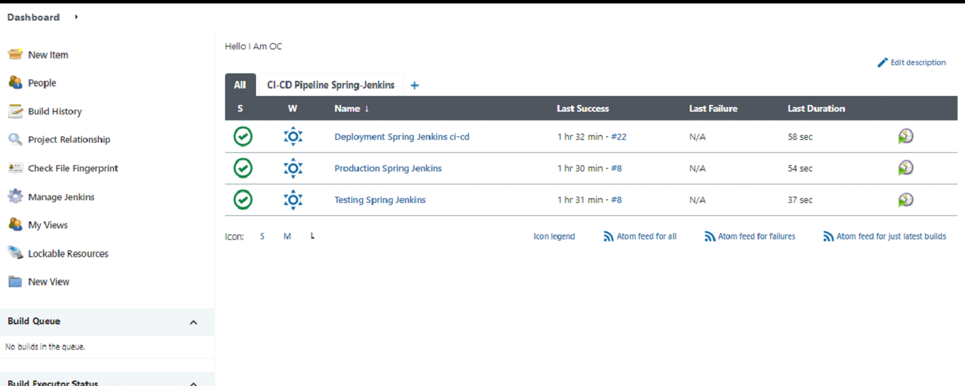



**Final Output:**

**Last host the application on AWS EC2 instance:**

